DS LAB ASSIGNMENT - CLA MT3

NAME: SAMPREETA JG
ROLL NUMBER: MA2411020010021

GITHUB REPOSITORY LINK:

QUESTION ATTEMPTED:
Module 1
- Smart Missing Value Handling with Business Rules
- Complex String Manipulation with Duplicate Handling
- Chunked Processing with Aggregation
Module 2
- Multi-File Data Wrangling
- Hierarchical Indexing & Custom Aggregation
- Combined Categorical Visualization

- Smart Missing Value Handling with Business Rules

- PROBLEM STATEMENT: You have a dataset where numerical or categorical values are missing, but simple mean/mode imputation would be inaccurate because the missing value depends on other features (e.g., a missing "Salary" depends on "Job Title" and "Experience").

- APPROACHES/ LOGIC USED:* Conditional Imputation: Group by categorical variables to fill missing values with the group-specific median.
Forward/Backward Fill: Use .ffill() or .bfill() for time-series data.
Flagging: Create an indicator column (e.g., is_missing) to let models know the data was absent.
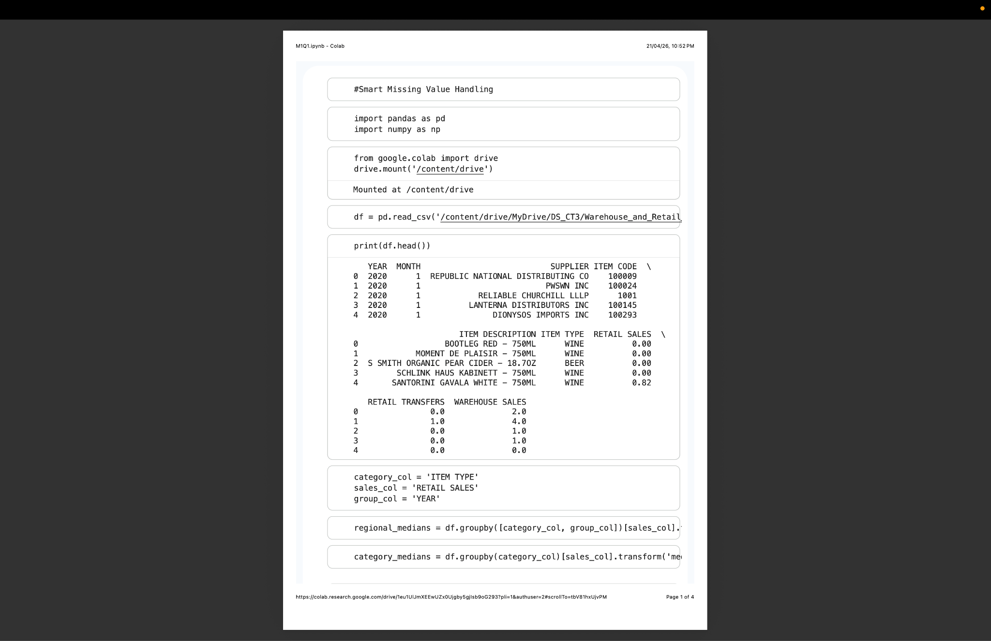
- Code:

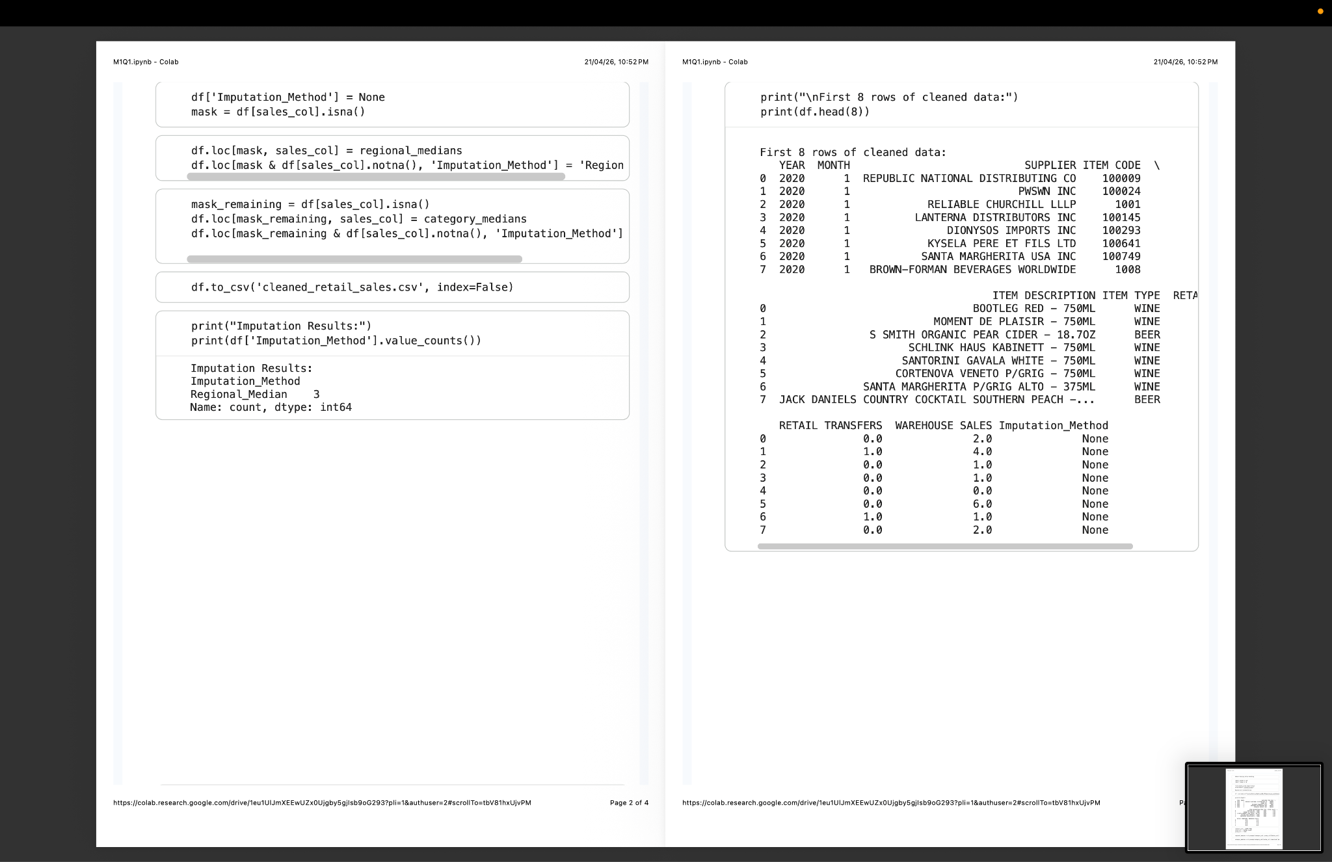
- Output:


- Challenge Faced: Avoiding "data leakage" (using information from the test set to fill values in the train set) and ensuring the business rules don't introduce bias.

- Key Insights: Context is king. Replacing a missing "Product Price" with the average of all products is worse than replacing it with the average of products in the same category.

- Complex String Manipulation with Duplicate Handling

- Problem Statement: A dataset contains "messy" strings—extra spaces, inconsistent capitalization, special characters, and near-duplicate entries (e.g., "Google Inc." vs. "google inc").

- Approaches/Logic:
  - Regex (Regular Expressions): Use str.replace() and str.extract() to strip non-alphanumeric characters.
  - Normalization: Convert all strings to lowercase and strip whitespace.
  - Fuzzy Matching: Use libraries like FuzzyWuzzy or Levenshtein to identify and merge strings that are 90% similar.

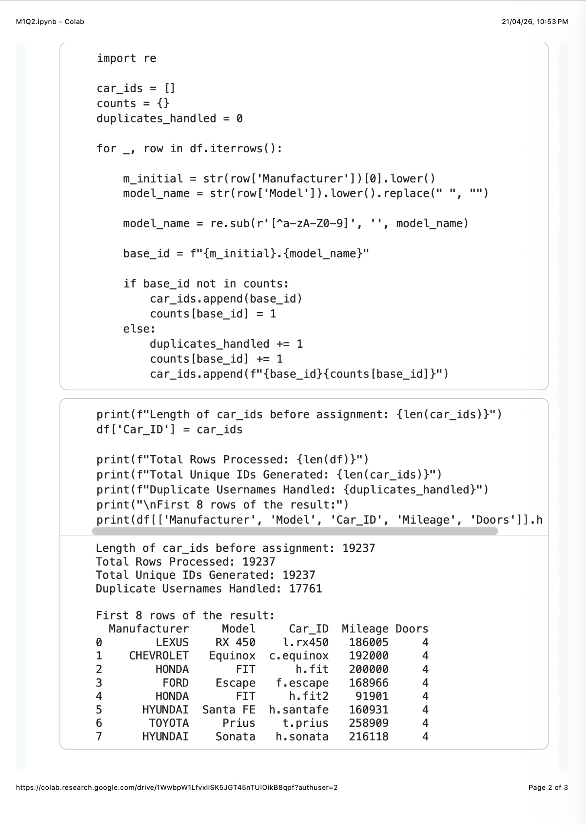
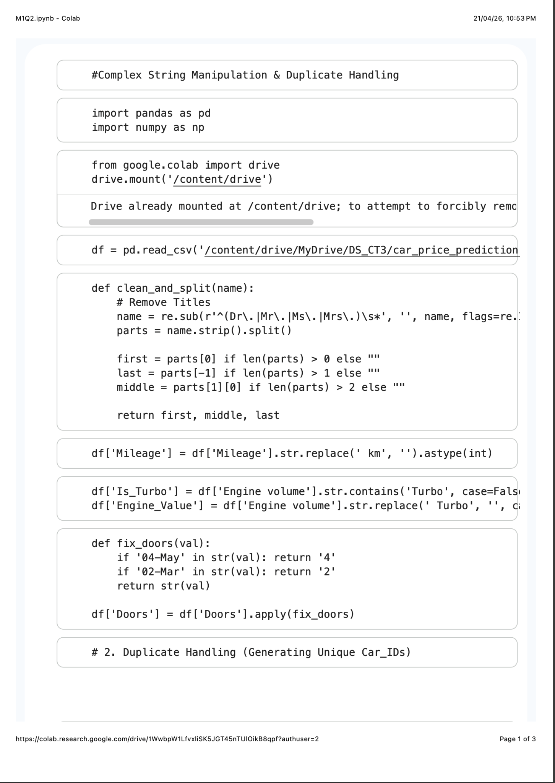
- Code:


- Output:
- Challenge Faced: High computational cost when comparing every string against every other string in large datasets.

- Key Insights: String cleaning should always be the first step in any data pipeline; "Google" and "google" are mathematically different until you normalize them.

3.Chunked Processing with Aggregation

- Problem Statement: You need to analyze a 10GB CSV file on a machine with only 8GB of RAM.

- Approaches/Logic:
  - chunksize Parameter: Read the file in smaller pieces (e.g., 100,000 rows at a time) using pd.read_csv(file, chunksize=100000).
  - Iterative Aggregation: Calculate partial sums and counts for each chunk, then combine them at the end.
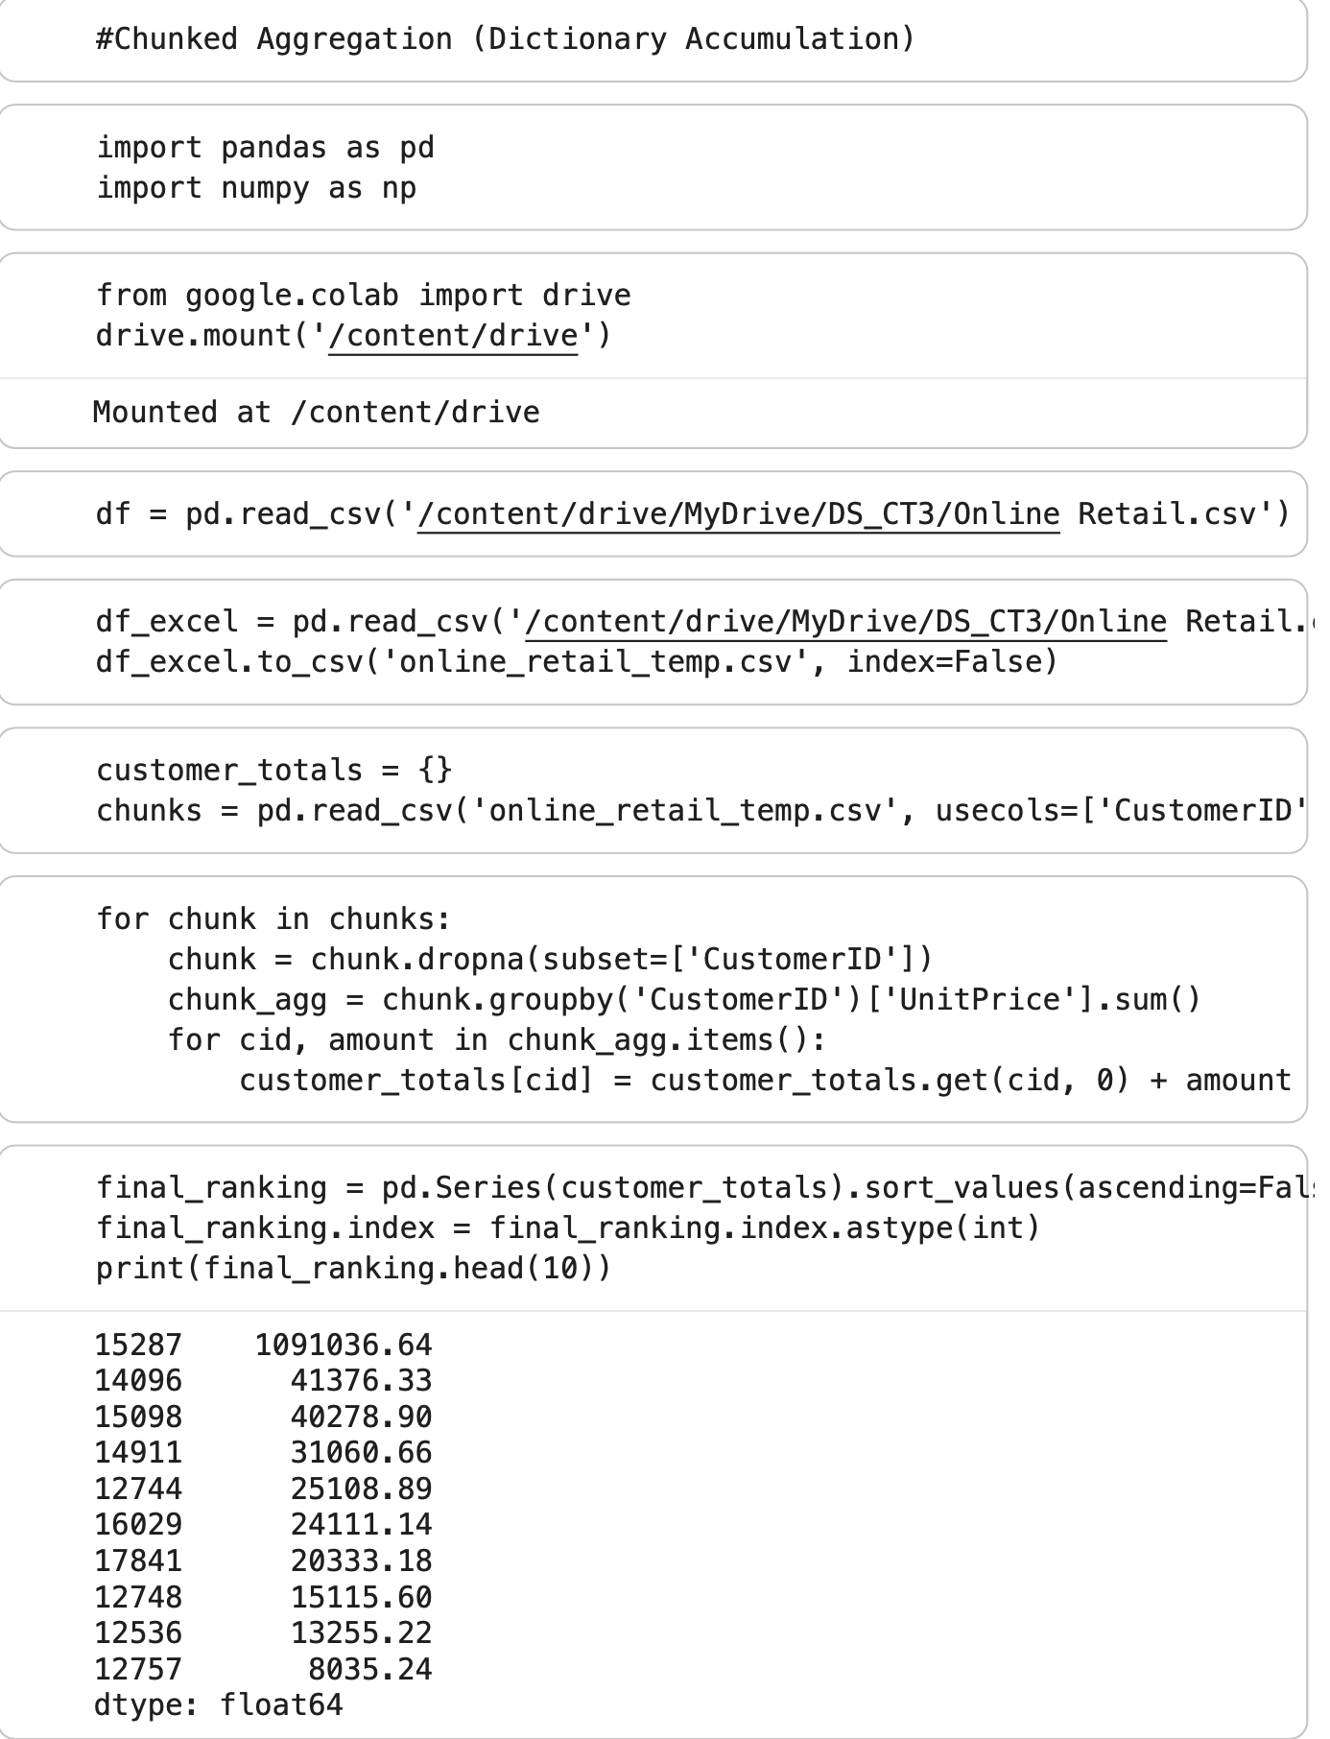
- Code:
- Output:

- Challenge Faced: Maintaining global statistics (like a global median) across chunks is significantly harder than calculating a global mean.

- Key Insights: You don't need to see all the data at once to understand it. Streaming data allows for processing "infinite" datasets on limited hardware.

4. Multi-File Data Wrangling
- Problem Statement: Data is scattered across multiple tables (e.g., Users, Orders, and Products). You must unify them to answer a business question.

- Approaches/Logic:
  - Joins/Merges: Use pd.merge() with inner, left, or outer joins based on the unique identifier (Primary Key).
  - Concatenation: Use pd.concat() to stack files with the same columns on top of each other.

- Code:
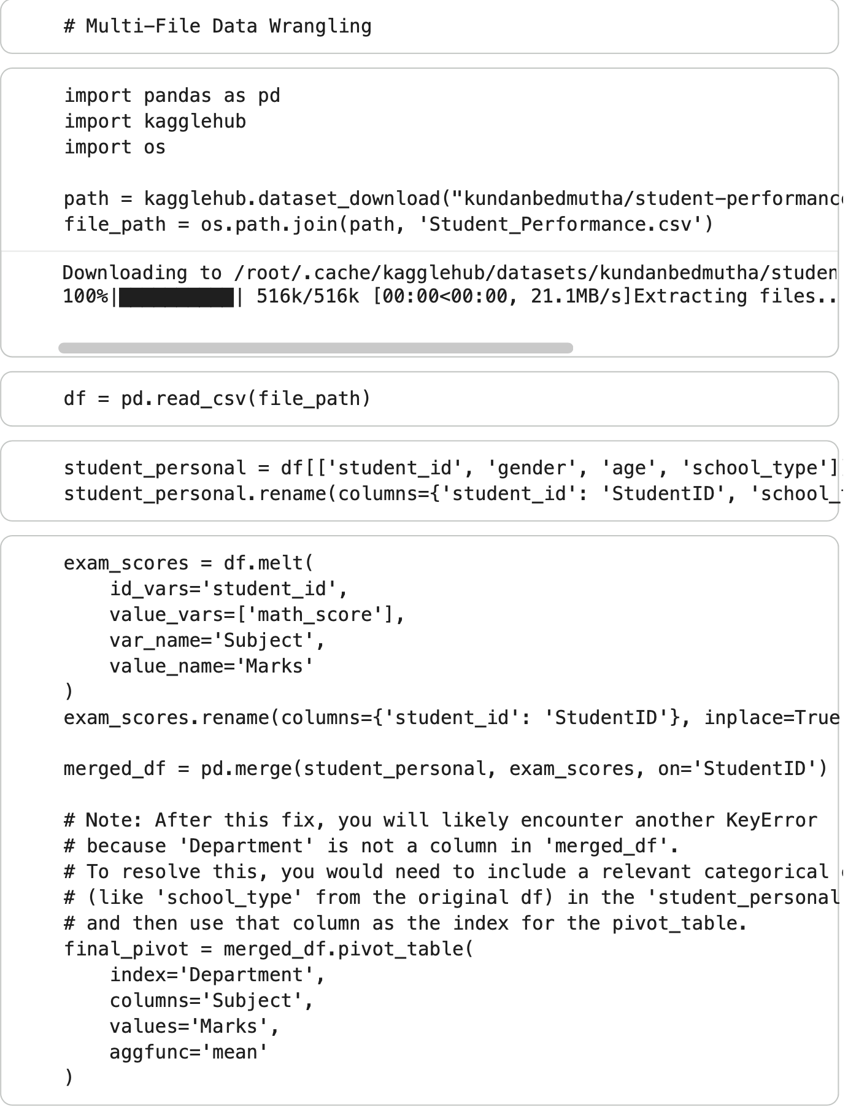
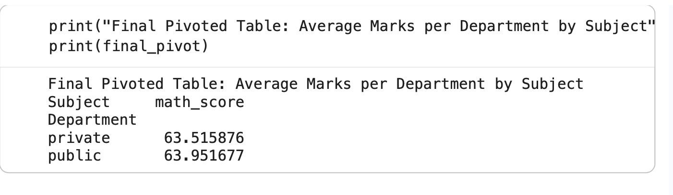
- Output:

- Challenge Faced: Handling "Many-to-Many" relationships which can cause row counts to explode and create duplicate data.
- Key Insights: Always check your row counts before and after a merge to ensure you haven't accidentally deleted data or created duplicates.
5. Hierarchical Indexing & Custom Aggregation
- Problem Statement: You need to analyze sales data across multiple dimensions (Region > State > City) and apply different math to different columns (e.g., Sum of Sales but Average of Profit).

- Approaches/Logic:
  - MultiIndex: Use .set_index(['Level1', 'Level2']) to create a nested hierarchy.
  - Named Aggregation: Use .agg(Total_Sales=('Sales', 'sum'), Avg_Profit=('Profit', 'mean')).
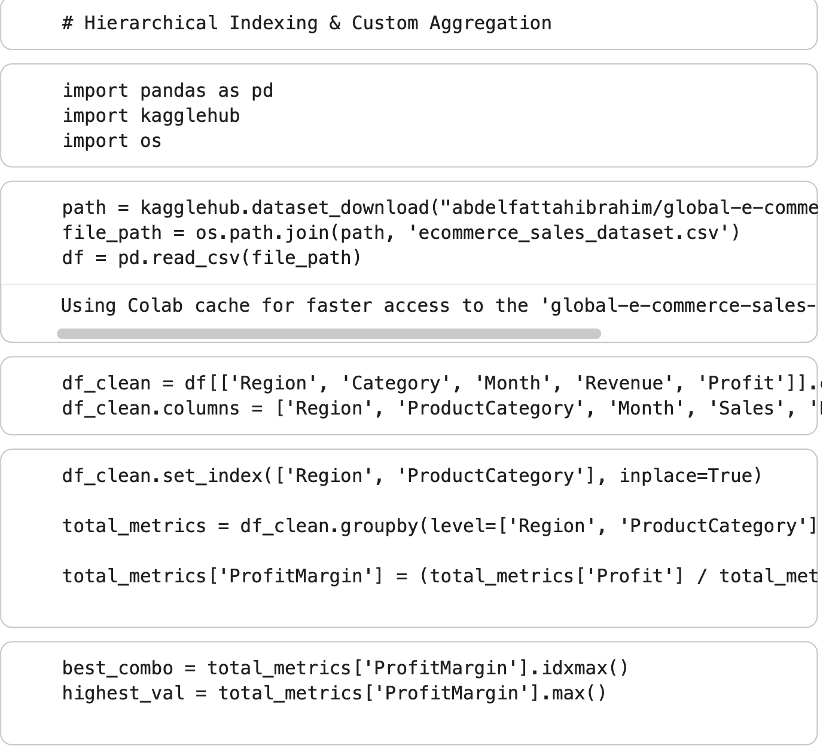
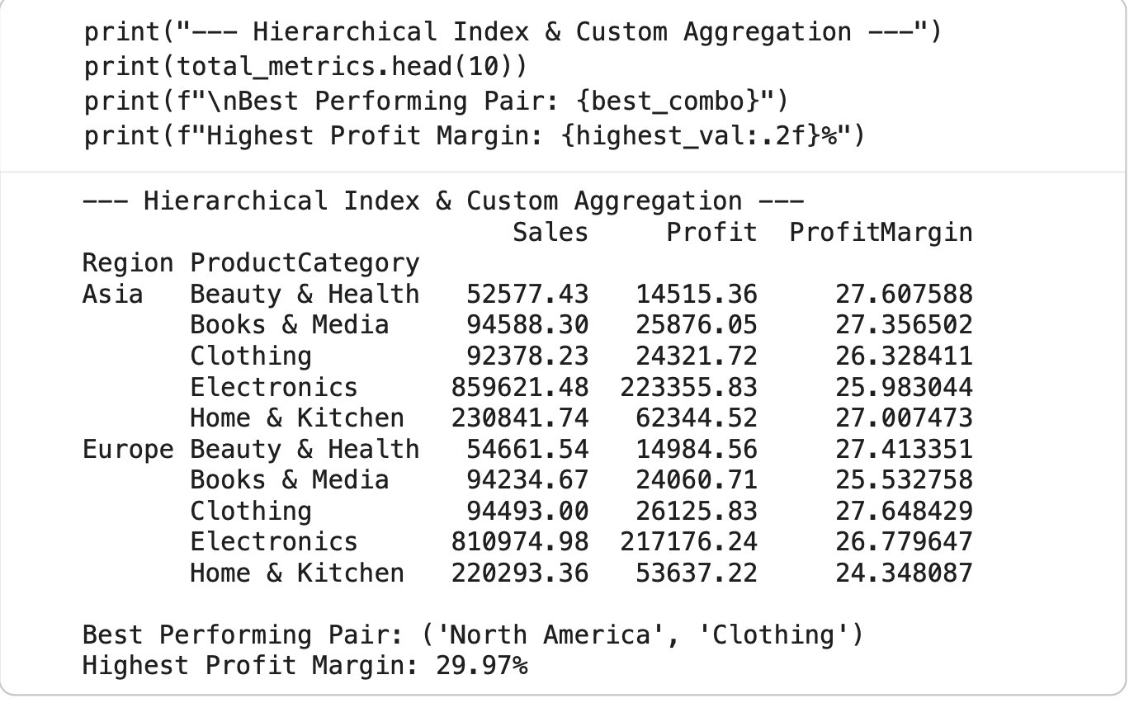
- Code:


- Output:
- Challenge Faced: Navigating and slicing a MultiIndex (using .loc) can be syntactically confusing compared to a standard flat table.

- Key Insights: MultiIndexing allows you to view high-dimensional data in a 2D format, making it easier to generate "Subtotal" style reports.

6. Combined Categorical Visualization
- Problem Statement: You need to show both the distribution of a variable and the frequency of that category in a single, high-density chart.

- Approaches/Logic:
  - Dual-Axis Plotting: Use a Boxplot or Violin plot for distribution and overlay a Bar chart (on a secondary Y-axis) for count.
  - Facet Grids: Use Seaborn’s catplot to break one large chart into multiple small multiples.
- Code:
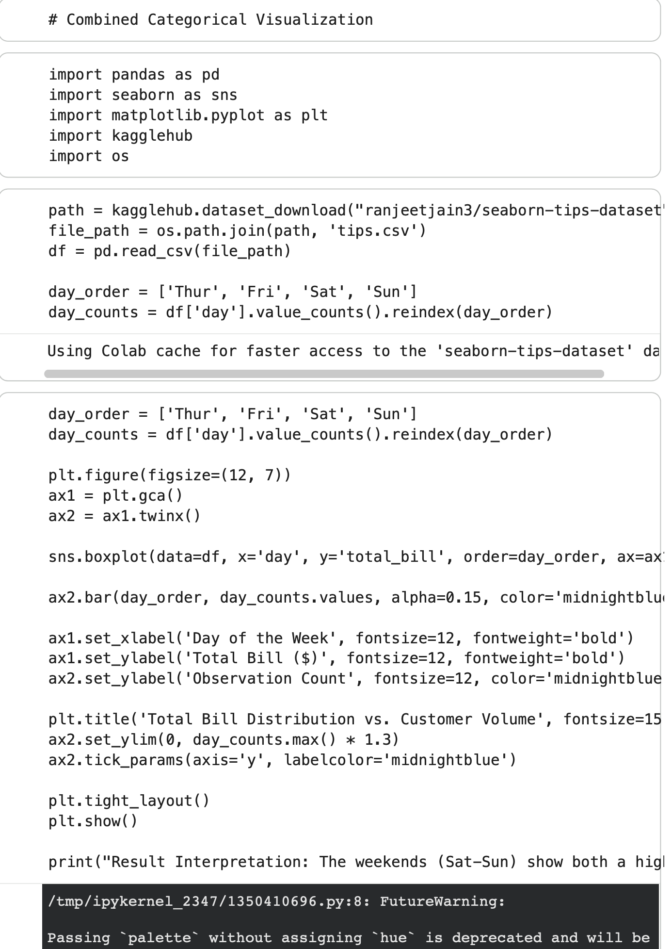
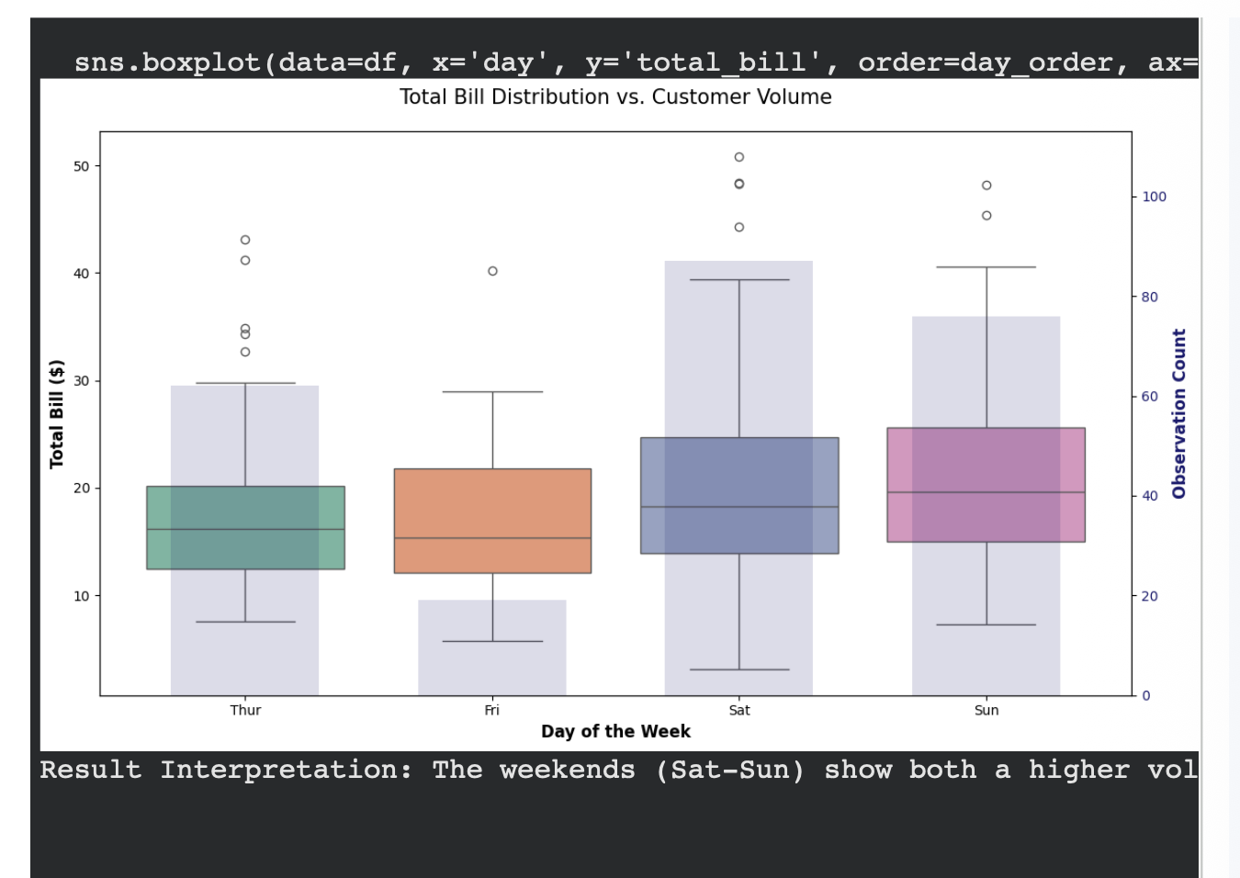
- Output:

- Challenge Faced: Visual clutter. Adding too much information to one chart can make it unreadable for stakeholders.

- Key Insights: An outlier in a boxplot is much more significant if you can see (via a bar chart) that the sample size for that category is very small.

